DCAC 100 - For the Colouring of Aluminium
DCAC100 – 铝材着色
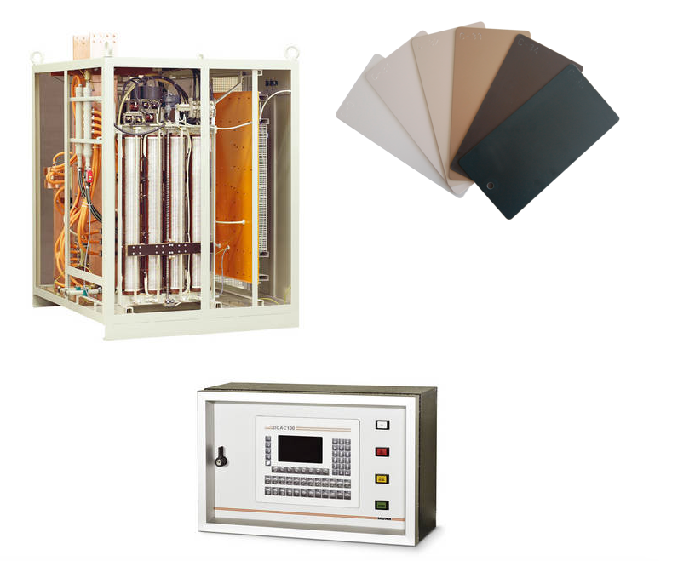

Application:
应用范围：
The DCAC 100 system will achieve a higher productivity due to the improved colour distribution and depth control. The user will gain technical sustainability with the DCAC concept which helps him to preserve the technical edge.
DCAC 100系统基于提高了颜色分布和深度控制将实现更高的生产率。用户将获得技术可持续性的DCAC技术理念, 将帮助他保持技术优势。
DCAC 100 systems are used and very much appreciated worldwide.
DCAC100系统获得了世界好评。

Product Description:
产品说明：
The DCAC 100 power supply consists of two main parts, the power section and the control panel which is integrated in a metal-enclosed housing for industrial purposes, directly installed at the process tank. The power section is offered in air- or water-cooled design.
DCAC 100电源包含两个主要部分,电源单元和一个集成在为工业用途的封闭式金属盒里控制面板；该控制盒可以直接安装在工艺槽的傍边。电源单元提供了空气或水冷式设计。
The special feature of this unit is a high-quality variable ratio transformer with silver-plated running surfaces which can be adjusted by means of a frequency converter. Therefore, a constantly good sinus current flow in the AC phase is guaranteed including the necessary reproducibilty regarding the surfaces that have to be coloured.
电源单元的特点是采用一个高质量的表面镀银的可变比变压器, 并且可以通过变频器调节。因此, 在交流阶段能够保证一个连续好的窦电流流动，激活需被着色表面的必要的活性。
Switching over from the starting DC phase is carried out wear-free.
Individual customized colouring programmes can be defined easily and retrieved any time thanks to the programme memory. Up to 200 different colouring programmes are possible.
从一开始到直流阶段的操作都可以无损耗的切换。个人定制的着色程序能够在任何时间内很容易的存取在程序记忆卡内，可存取多达200种不同的着色程序。
Another feature of the DCAC 100 power supply, the integrated automatic load adjustment, enables the operator to achieve the same colour shade for various load sizes without having to change the programme.
DCAC 100电源的另一个特点是集成自动负载调整,使操作员能够实现为各种负载大小相同的色度而无需改变程序。
The system is technically prepared for the interference system ALU-SPECTRAL.
该系统集成了ALU-SPECTRAL无干扰系统技术。
Compared to the well-known alternating current (AC) colouring systems, the DCAC 100 power supply ensures higher productivity due to an improved colour distribution. The load size can be increased compared to AC systems.
与众所周知的交流电(AC)着色系统比较, DCAC100电源基于一种改进的颜色分布技术能确保更高的生产率。相对于交流系统，提高了负载的大小。

Customer Benefits:
客户利益：
The DCAC power supply with a solid cooling concept offers a long and reliable use under tough industrial conditions.
DCAC电源的立体冷却的设计符合长期在一个艰难的工业条件下可靠使用。
The DCAC system allows the user to invest in a proven concept which leads to a high process reliability and also provides advantages in quality and efficiency in the national and international competition.
DCAC系统引导客户投资在一个久经考验的设计理念并且提高其产品的生产稳定性；同时面对国内外竞争，提高质量和效率优势。

Technical Data:
技术参数：
Connection Voltage:  输入电压： | 2 x 400 V / 50 Hz
Ambient Temperature:  环境温度： | 40 °C
Cooling:  冷却方式 | Water or air  水或风
Water inlet Temperature:  进水温度： | 15 °C - 25 °C
Water outlet Temperature:  出水温度： | 28 °C - 35 °C
Flow Rate:  流量 | 1,0 m³/h
Power Part
电源部分：
Dimensions (W/D/H):  尺寸（W/D/H）: | 1400 / 1200 / 1800 [mm]
Weight:  重量： | 1500 kg
Finish:  颜色： | RAL 7032
Control Part
控制部分：
Dimensions (W/D/H):  尺寸（W/D/H）: | 600 / 235 / 380 [mm]
Weight:  重量： | 35 kg
Finish:  颜色： | RAL 7035

Drawing:

